Work Process
1.In Master on Main Server There Message Broker is installed
2.All Server like Master and Childs will create and read messages from Message broker.
3.Each Server has a track of data in the database and tries to create a Message when it has data to sync.
4.After Sync each Server Create a confirmation message that this data has been synced.

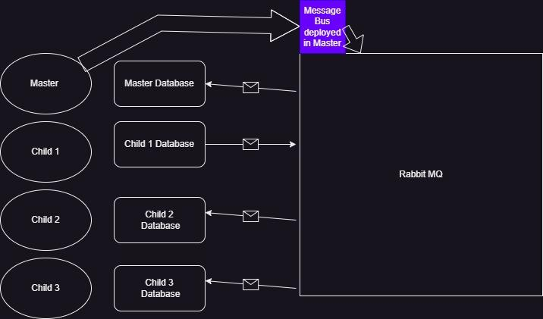

Steps to Config the System of use this
1.need to install RabbitMQ Message Broker INnMaster or Main server
https://www.rabbitmq.com/install-windows-manual.html

2.add config to in app Settings:
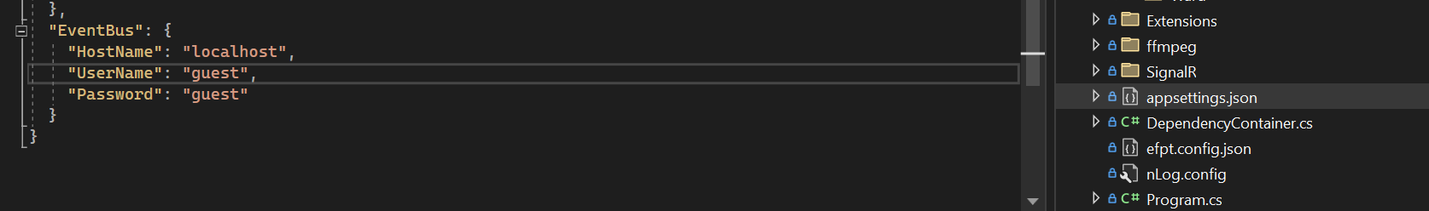
3.Register RabbitMQ in Startup
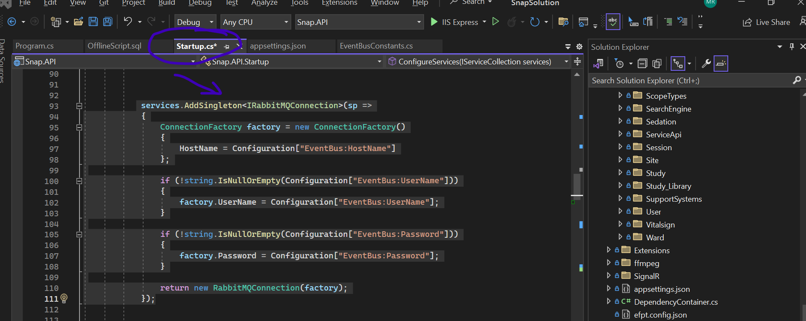


Register Producer
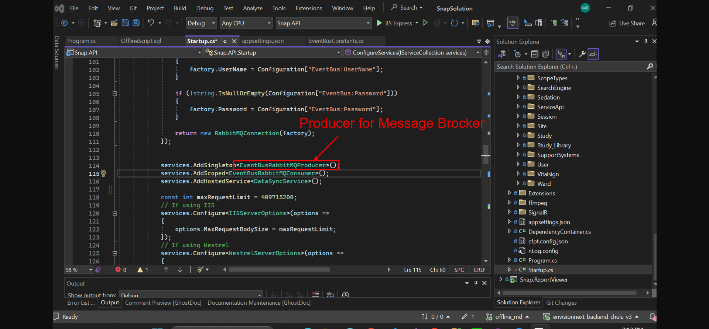
Register Consumer
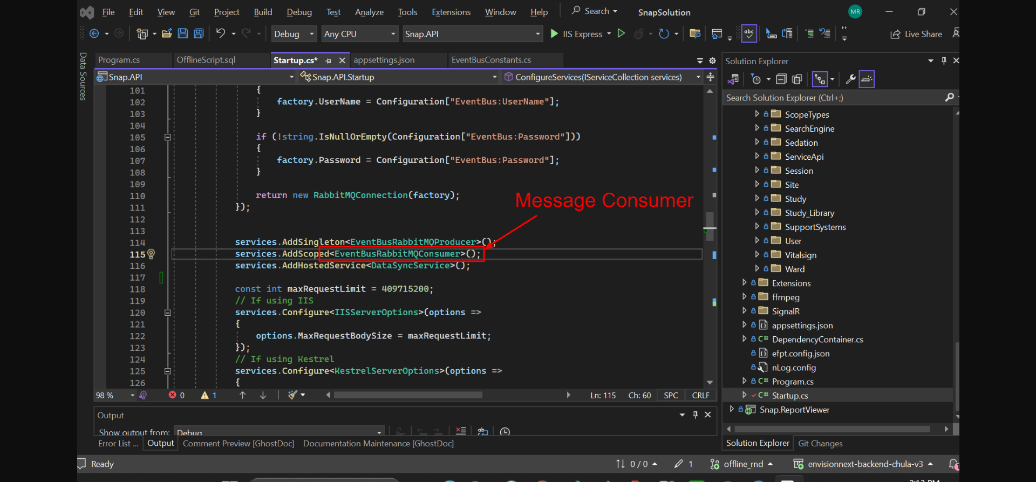
Register Background Service
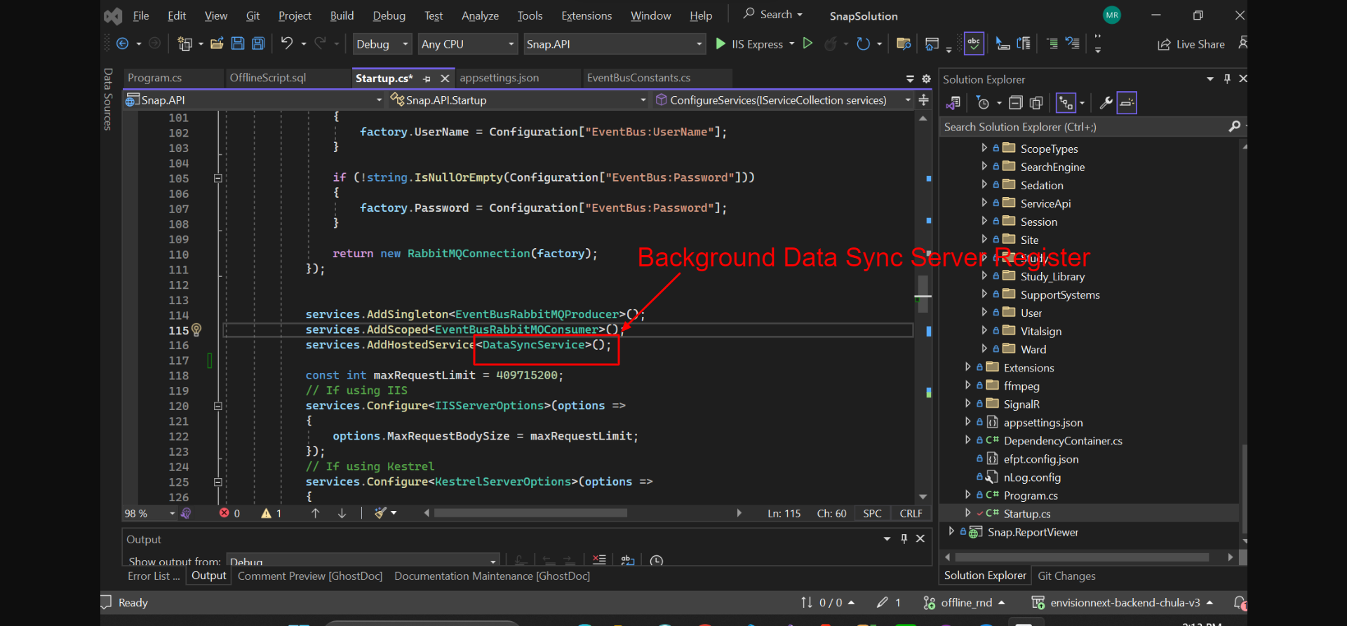

Download code for Consumer Producer and RabbitMQ Connection

Background Data Sync Service
using EventBusRabbitMQ.Common;
using EventBusRabbitMQ.Events;
using EventBusRabbitMQ.Producer;
using Microsoft.Extensions.Hosting;
using Microsoft.Extensions.Logging;
using Newtonsoft.Json;
using Snap.Data.CustomModels;
using Snap.Repository.ChildOfflineDataSync.Interface;
using Snap.Services.ChildOfflineDataSync.Interface;
using Snap.Services.Common.Interface;
using System;
using System.Linq;
using System.Runtime.Intrinsics.X86;
using System.Threading;
using System.Threading.Tasks;

namespace Snap.API.BackgroundServices
{
public class DataSyncService : BackgroundService
{
private readonly ILogger<DataSyncService> _logger;
private readonly EventBusRabbitMQProducer _eventBus;
private readonly IChildDataSyncService _childDataSyncService;

public DataSyncService(ILogger<DataSyncService> logger, EventBusRabbitMQProducer eventBus, IChildDataSyncService childDataSyncService)
{
_logger = logger;
_eventBus = eventBus;
_childDataSyncService = childDataSyncService;
}

protected override async Task ExecuteAsync(CancellationToken stoppingToken)
{
try
{
while (!stoppingToken.IsCancellationRequested)
{
RequestedModel dataItem = _childDataSyncService.GetFirstOrDefaultUnsyncData();
if (dataItem != null)
{
try
{
_eventBus.Publish(dataItem.QueueName, new PatientInfoModelEvent { Key = dataItem.RequestedEventName, SourceQueueName = dataItem.SourceQueueName, Id = dataItem.Id, item = JsonConvert.DeserializeObject<PatientInfoModel>(dataItem.RequestedData) });
_childDataSyncService.UpdateRequestedStatus(dataItem.Id, true);
}
catch (Exception ex)
{
_childDataSyncService.UpdateRequestedStatus(dataItem.Id, false);

}

}

await Task.Delay(10000, stoppingToken);

}
}
catch (Exception ex)
{
await ExecuteAsync(CancellationToken.None);

}

}
}
}

5. If new data or trying to sync data then save data in CHILD_DATA_SYNC Table

